**Toggle Hidden Properties**

This document explains about another feature of Task Editor i.e Toggle Hidden Properties.  
This feature allows you to Expand & Collapse the properties of an Action, and user can see the Changes in Property Panel which is to the right side of the Task Editor.

**Step1:** Open **Task Editor** of Zap Automation.

**Step2:** Select **View** menu from menu bar and select **Expand Hidden Properties.**

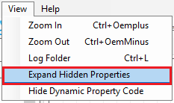

**Step 3:** Once you click on **Expand/Collapse Hidden Properties** option then click anywhere on the Task Editor. Select any Action for which you want to see the **Expanded/Collapsed** properties.

**Step4**: When you select **Expand Hidden Properties** option, then all hidden properties of action are expanded as shown in the picture below, But Normally, optional properties are hidden as shown below

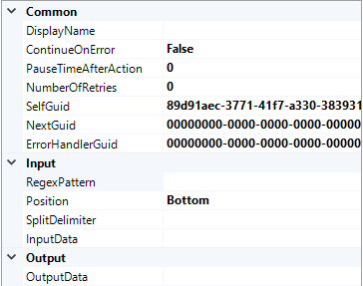

But normally optional properties are hide like as,

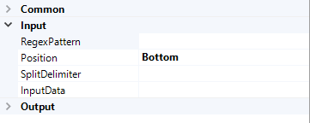

**Step5:** To set normal properties of action, go to View menu in Menu bar select Collapse Hidden Properties option.

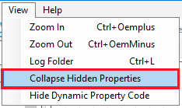

**Step6:** Once Collapsed the properties are shown as below,

